**Henry Stiefel**

**CS 4092-001**

**NBA Database Design Project**

**Write Up**

The NBA domain that I built within my DBMS centers around data in three categories – player, coach, and team statistics. Each of these three categories has data for 5 seasons – stored as one season in one data table. There is an additional table matching team names to team codes, making a total of 16 tables in my schema.

**20 Questions**

1. Which teams had a winning record in 2021?
2. Which players scored more than 500 total points in 2021?
3. Which players, on Pacific division teams, either led the team in points per game (minimum 20) or led the team in rebounds per game (minimum 10)?
4. Which coaches coached teams with losing records?
5. Which coaches currently coach a team which has had a winning record over the last 5 years?
6. What was the average points per game amongst all players in 2020?
7. Which player scored the most points per game in 2021?
8. Which teams in the Eastern Conference had a winning record last season?
9. Who was the top rebounder in the Western Conference last season?
10. Who were the players with the most assists per game, and who is their coach?
11. Which players are in the top 10 for three-point percentage with a minimum of 100 three point attempts?
12. Who are the league leaders for points, assists, and rebounds per game?
13. Who are the coaches of the Atlantic division?
14. Who are the top scorers on teams with a Net-Adjusted Rating (nRtgA) greater than 3?
15. Which player has the best field-goal percentage on each team with a minimum of 100 field goal attempts?
16. Which players in the league are small forwards and average at least 1 steal per game?
17. Who coaches the players in the league who are small forwards and average at least 1 steal per game?
18. Which players average 20 points, adjusted per 36 minutes, but average less than 15 points per game and greater than 10 minutes per game?
19. Which teams’ city name starts with a C?
20. Who are all the players in the Eastern Conference who started more games than they came off the bench?

**Database Design Diagram**

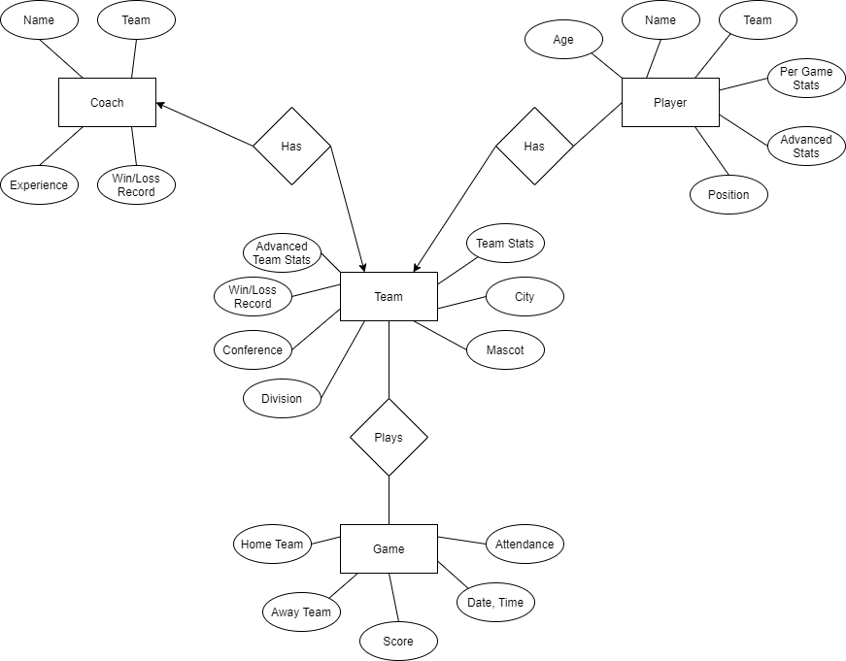

**‘CREATE TABLE’ Statements I Used:**

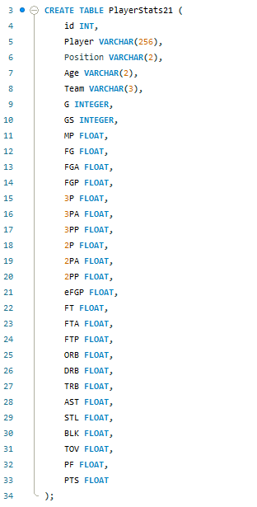

The above SQL snippet is the creation I used for tables containing player stats. Each player has an ID, name, team, position, etc. All of the stats recorded in that table correspond to the year denoted in the table name, and are per-game statistics – so the above table holds 2020-21 PPG, APG, 3P%, etc.

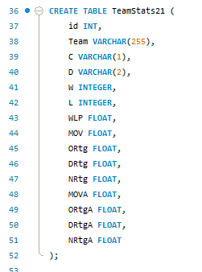

This SQL statement creates the tables for holding team statistics. Each team has their ID, name, conference, division, wins, losses, etc. There is a separate table for each season.

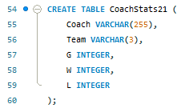

This SQL statement creates the coach statistics tables, again corresponding to the year in the table name. Each coach has their name, team they coached, games, wins, and losses.

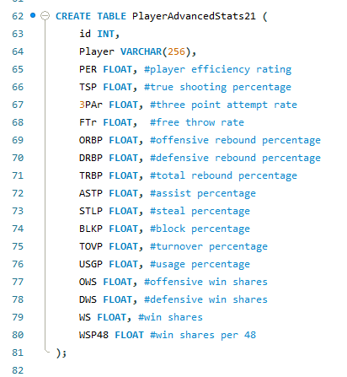

This SQL statement is for creating the tables which hold player advanced statistics. Comments are included to give definitions to the statistic metrics which may be less well-known.

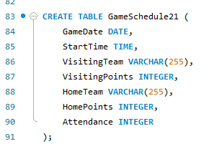

This SQL statement creates the tables for holding game results for the 2020-21 season. The game’s date, tip-off time, home and visiting team name plus scores, and attendance are tracked. One row corresponds to one game that was played in the season.

**How I Populated My Database**

My database was populated using statistics from <https://www.basketball-reference.com/>. They allow users to easily format and download the data as a CSV file. The player statistic data required some extra editing, because a lot of the foreign and international players had special characters in their names. This required the CSV to be specified as UTF-8 format before being imported into the MySQL DBMS. As far as populating the DBMS, once I had CSVs for each category and season, I used the MySQL Workbench Table Import Wizard, which quickly and easily matched the data to the correct tables and columns.

**20 Questions SQL Query and Results**

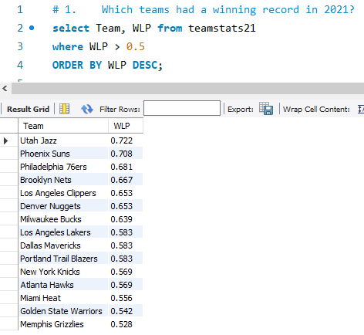

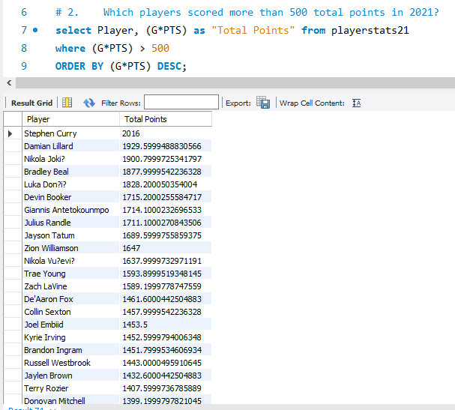

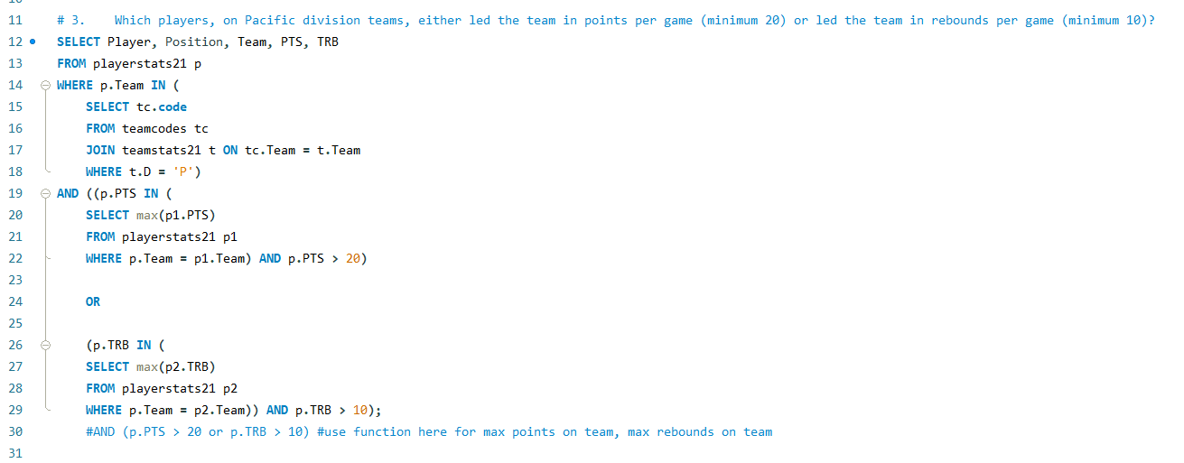

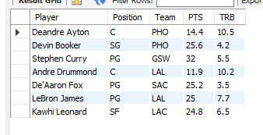

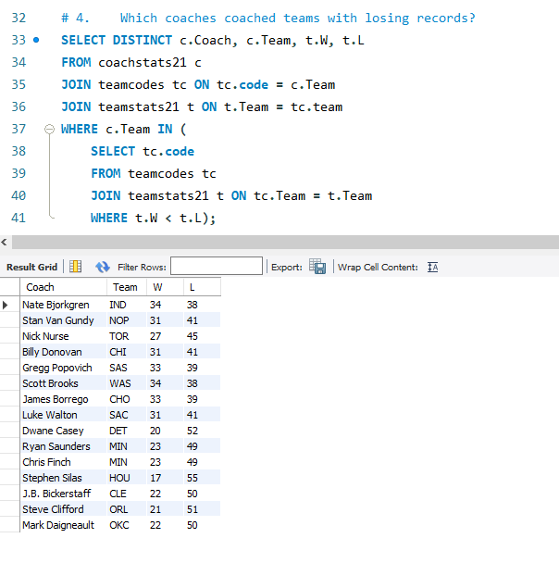

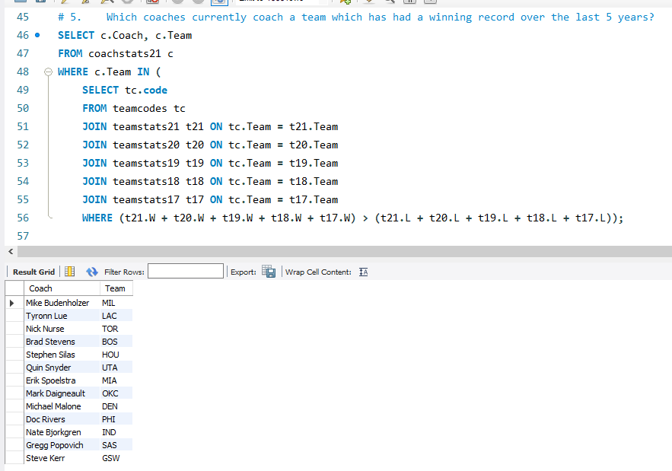

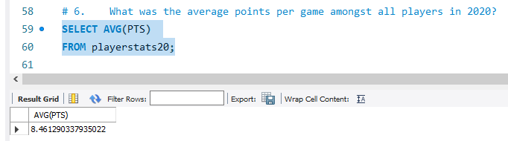

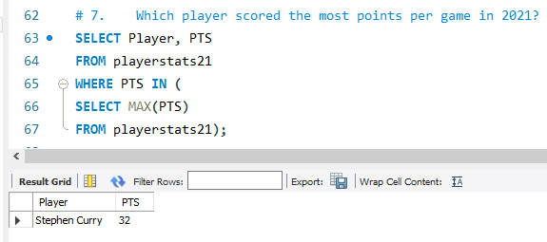

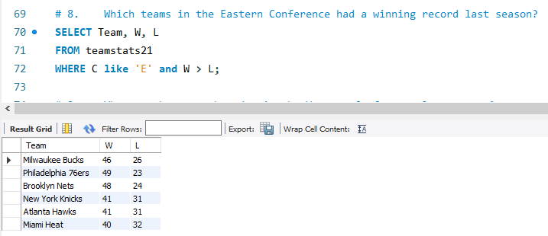

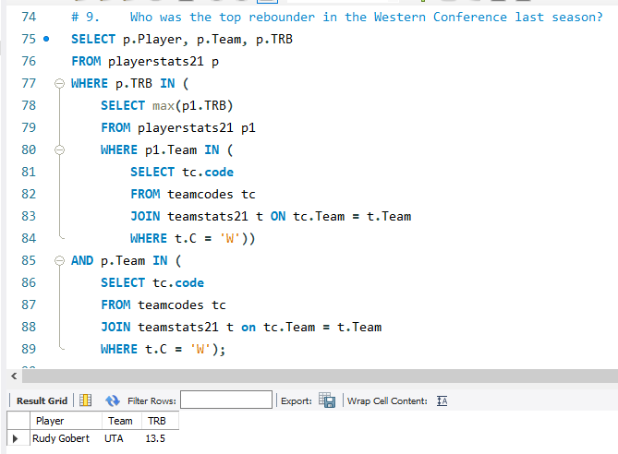

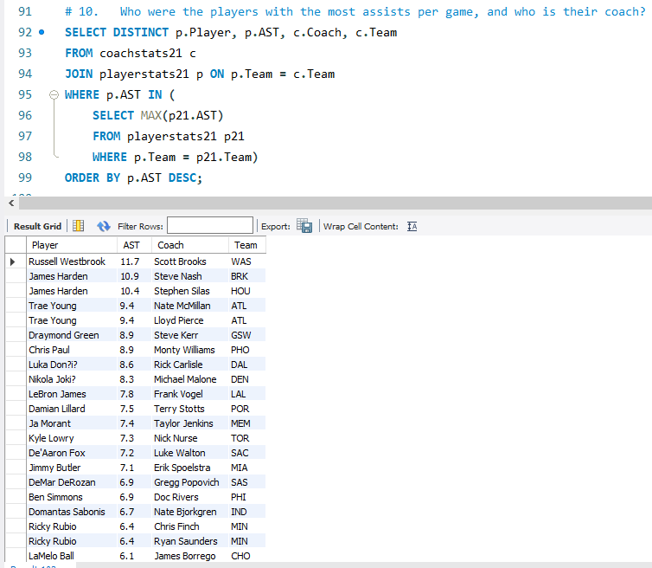

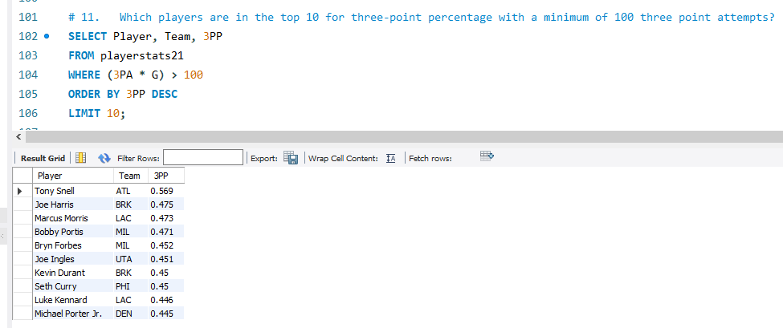

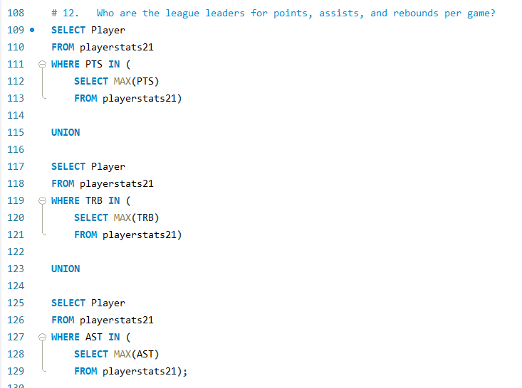

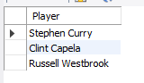

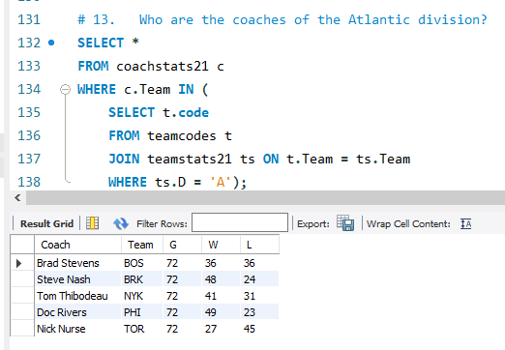

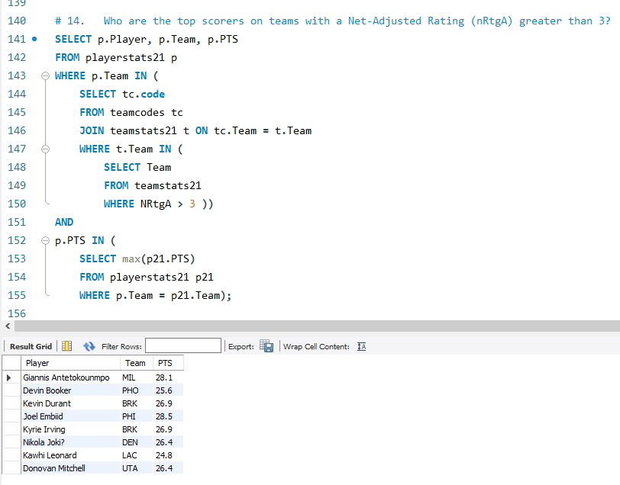

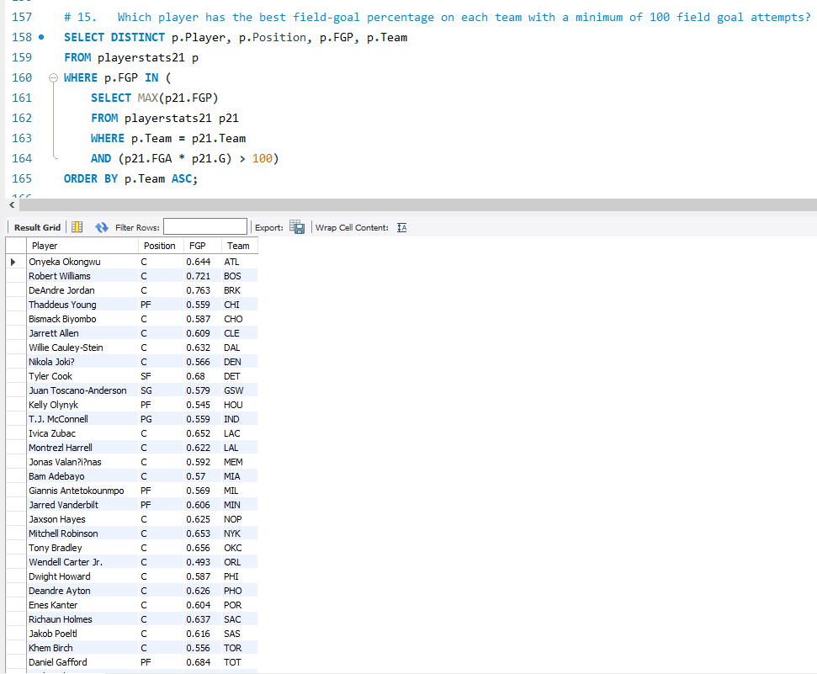

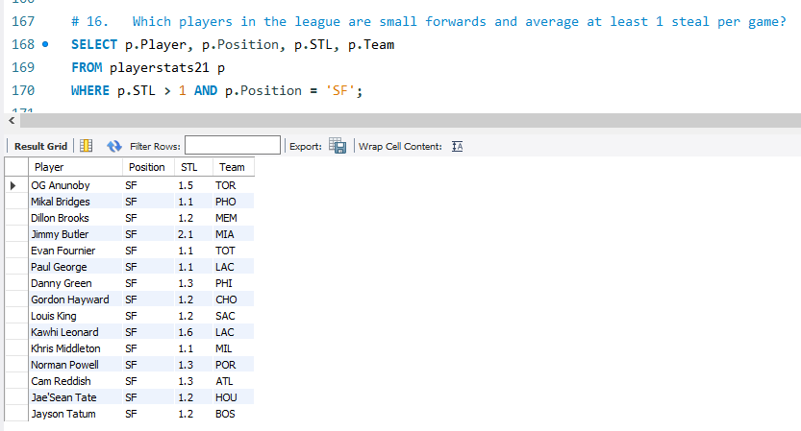

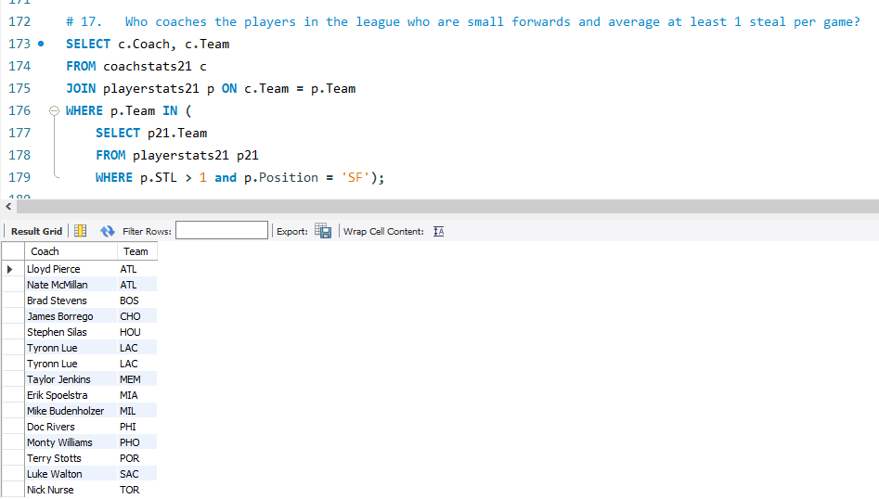

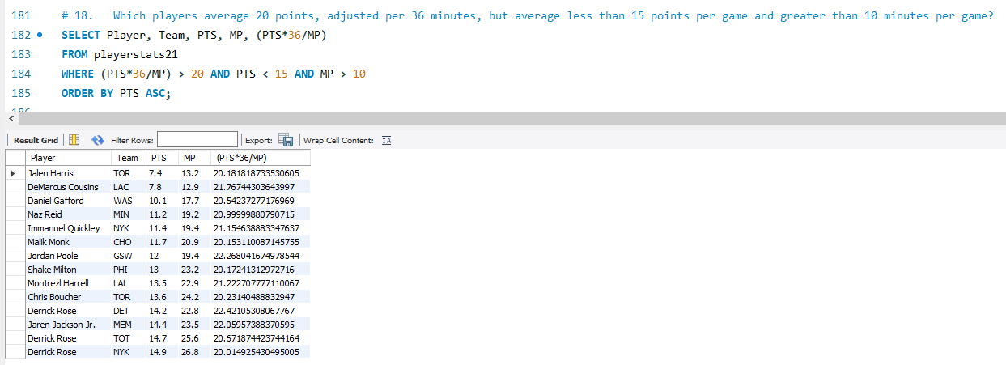

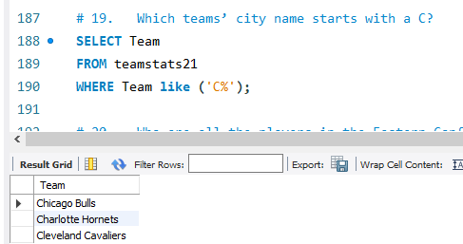

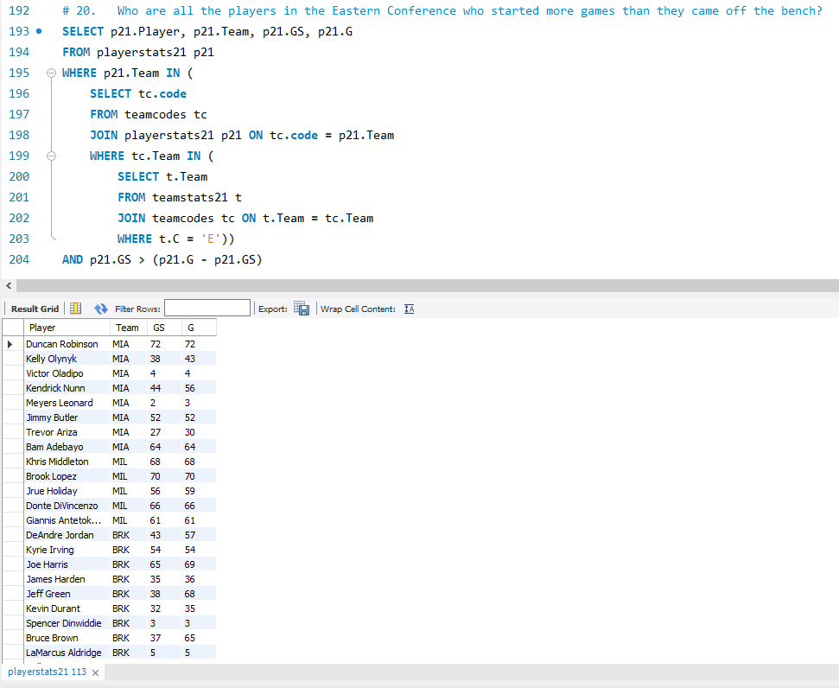

**CRUD Stored Procs For Adding, Updating, and Removing Data**

Firing Old Coach, Hiring New One

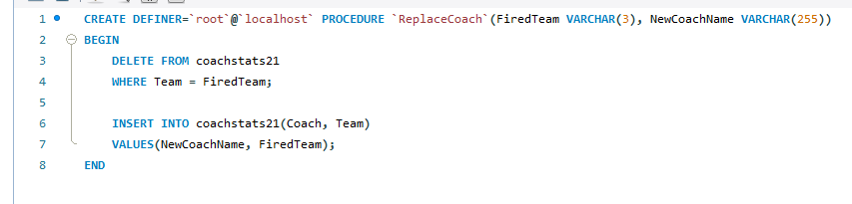

Trading Two Players

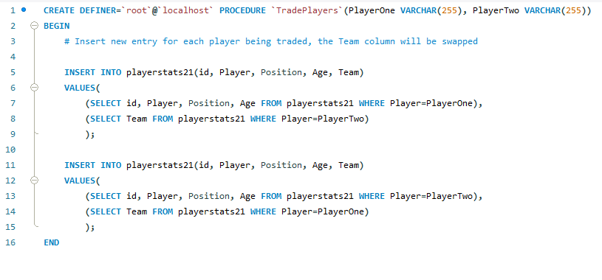

Expelling a Player from the League

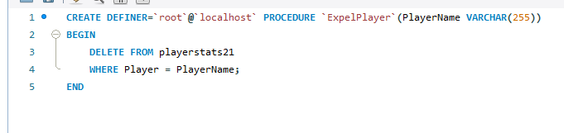

Drafting a New Player

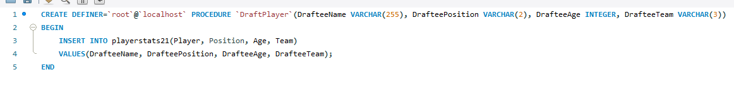

**Listing of Contents of All Tables**

Contents of Player Stats Table:

* 500-600 rows per season
* Each row represents a player’s stats for that season. If a player was traded in the middle of the season, they will have one row for each team they were a member of
* Columns for player biography information and per-game stats
  + Name, age, position, team
  + Points, assists, steals, rebounds, blocks, turnovers, fouls, minutes played
  + Percentages for field goals, three pointers

Contents of Coach Stats Table:

* ~30 rows
* One row per coach. Some teams have more than one coach listed, if they fired a coach and hired a new one in the middle of the season
* Columns for coach name, team, games coached, wins, and losses

Contents of Team Stats Table:

* 30 rows, one for each team
* Team city and name, games played, wins, losses
* Team’s conference and division
* Advanced statistics including offensive rating, defensive rating, net rating, and adjusted rating

**Listing of Source Locations for Data**

<https://www.basketball-reference.com/leagues/NBA_2021_per_game.html>

<https://www.basketball-reference.com/leagues/NBA_2021_coaches.html>

<https://www.basketball-reference.com/leagues/NBA_2021_standings.html>

**Tutorials Used For Help**

I did use several resources and online guides whilst I had questions working on this project. They are listed below.

<https://www.youtube.com/watch?v=OnXB3ZRrOW0&ab_channel=MattMacarty>

<https://www.youtube.com/watch?v=36qsFq1z-4o&ab_channel=ProCodeNetwork>

<https://www.youtube.com/watch?v=AH0-eAVWpG4&t=113s>

<https://www.youtube.com/watch?v=WzMjd3AOX8U&ab_channel=MattMacarty>

<https://www.tutorialspoint.com/How-can-I-create-a-stored-procedure-to-update-values-in-a-MySQL-table>

<https://www.tutorialspoint.com/How-can-I-create-a-stored-procedure-to-delete-values-from-a-MySQL-table>